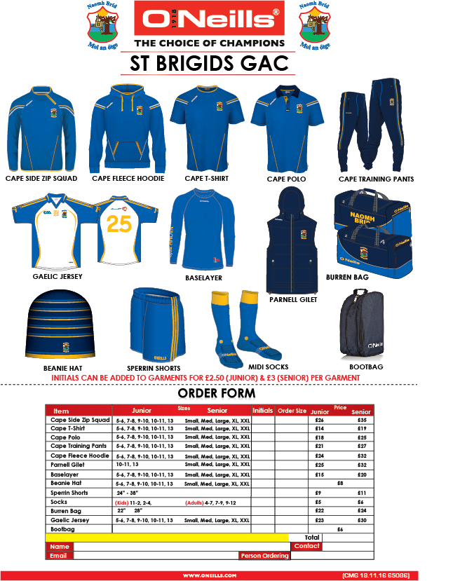
Please return your completed form with payment to your team Coach or
Anthony Carleton –AnthonyCarleton@sky.com or Muiris MacCarthaigh –m.maccarthaigh@qub.ac.uk

