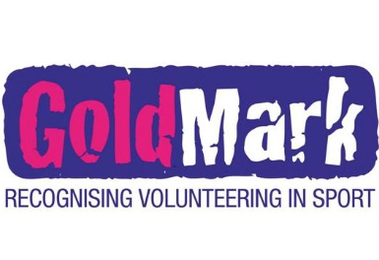
GoldMark Registration Form

Club __________________________

Name __________________________

Email ______________________________

Postal Address ________________________________________
________________________________________
________________________________________

Contact Number _____________________________________

DOB ________________

Club Co-Ordinator __________________________

Club Co-Ordinator Email _______________________________

